What Is the Narcotics Anonymous Program?  NA is a nonprofit fellowship or society of men and women for whom drugs had become a major problem. We are recovering addicts who meet regularly to help each other stay clean. This is a program of complete abstinence from all drugs. There is only one requirement for membership, the desire to stop using. We suggest that you keep an open mind and give yourself a break. Our program is a set of principles written so simply that we can follow them in our daily lives. The most important thing about them is that they work. There are no strings attached to NA. We are not affiliated with any other organizations. We have no initiation fees or dues, no pledges to sign, no promises to make to anyone. We are not connected with any political, religious, or law enforcement groups, and are under no surveillance at any time. Anyone may join us regardless of age, race, sexual identity, creed, religion, or lack of religion. We are not interested in what or how much you used or who your connections were, what you have done in the past, how much or how little you have, but only in what you want to do about your problem and how we can help. The newcomer is the most important person at any meeting, because we can only keep what we have by giving it away. We have learned from our group experience that those who keep coming to our meetings regularly stay clean. |  | Meeting Directory  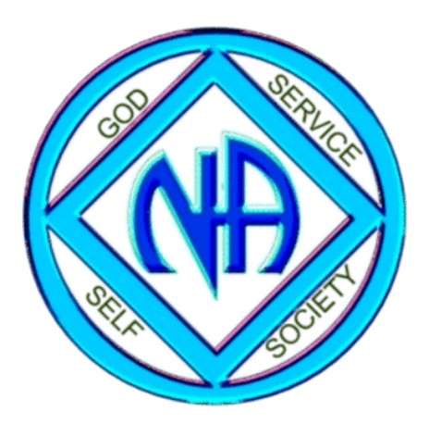  MOKAN AREA OF NARCOTICS ANONYMOUS    www.mokanna.org
  Phone Numbers
  ___________________________
  ________________________________________________________________________________________________________________________________________________________________________________________________________________________________________________________________________________________________________________________________________________________________________________________________________________________________________________\\\____________________
  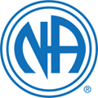
  Area Service Committee Meeting
  Alternates between St Joseph at Opportunity for Hope and Maryville at Never Alone. The meeting is held the first Sunday of each month at 1pm.
MARYVILLE, MO  Never Alone  Countryside Christian Church  24899 Icon Road  Monday - 6pm  Tuesday - 6pm  Thursday - 6pm  Saturday - 12pm  ________________________________  VIRTUAL/IN-PERSON MEETING SEARCH  www.na.org/meetingsearch/virtual-meeting-search | ST. JOSEPH, MO  New Attitudes  First Christian Church  927 Faraon Street  Monday - 8pm  Thursday - 8pm  ________________________________  Subject to Change  Restoration Church  117 Francis St  Sunday - 6:30pm  Tuesday - 6:30pm  Friday - 6:30pm  ________________________________  Opportunity for Hope  629 S 8th Street  Everyday - 7pm  ________________________________ | Who Is An Addict?  Most of us do not have to think twice about this question. We know! Our whole life and thinking was centered in drugs in one form or another — the getting and using and finding ways and means to get more. We lived to use and used to live. Very simply, an addict is a man or woman whose life is controlled by drugs. We are people in the grip of a continuing and progressive illness whose ends are always the same: jails, institutions, and death.  ________________________________  We Do Recover  When at the end of the road we find that we can no longer function as a human being, either with or without drugs, we all face the same dilemma. What is there left to do? There seems to be this alternative: either go on as best we can to the bitter ends – jails, institutions or death – or find a new way to live. In years gone by, very few addicts ever had this last choice. Those who are addicted today are more fortunate. For the first time in man’s entire history, a simple way has been proving itself in the lives of many addicts. It is available to us all. This is a simple spiritual – not religious – program, known as Narcotics Anonymous.

